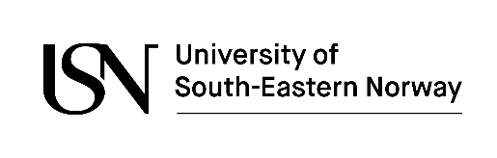
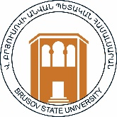
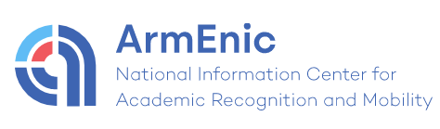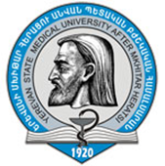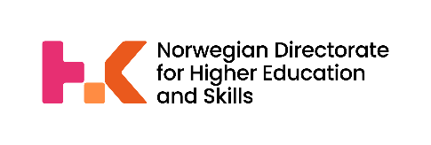

NACAR - Norwegian – Armenian Cooperation in Admission and Recognition
Final Seminar
Date: Friday May 13, 13:30 – 17:30
Venue: Brusov State University,
1st building, 2nd floor, Conference Hall

Armenian project partners: | Norwegian project partners:
ArmENIC | NOKUT
Brusov State University | University of South-Eastern Norway
Yerevan State Medical University

Programme
13:30 – 14:00 | Registration and coffee
14:00 – 14:05 | Official welcome by Brusov State University
14:05 – 14:10 | Official welcome by the Ministry of Education, Science, Culture and Sports
14:10 – 14:20 | Welcome from Norwegian participants  NOKUT and the University of South-Eastern Norway
14:20-14:30 | NACAR project overview  ArmENIC
14:30 – 14:50 | Norwegian Education System  Nokut
14:50– 15:10 | Armenian qualifications in Automatic Recognition  NOKUT
15:10 – 15:40 | Coffee break
15:40 – 16:15 | Presentation of the project report (Manual)  Presentation by USN, BSU, YSMU
16:15 – 17:00 | Recognition procedures for refugees’ qualifications  NOKUT and ArmENIC.
17:00 – 17:30 | Reception at BSU, 2nd building, 3rd floor, 306 room

